
School: ............................................................................................................. Campus: ....................................................... Academic Year: ...................... Subject Name: ........................................................... Subject Code: ..........................
Semester: ............... Program: ........................................ Branch: ......................... Specialization: .......................... Date: .....................................
(Learning by Doing and Discovery)
* Coding Phase: Pseudo Code / Flow Chart / Algorithm
Process for Dissecting a Transaction
• Step 1: Collect Your Transaction
- Open your Solidity IDE (for example, Remix) in your browser.
- Create a new Solidity file and save it.
- Connect your browser to MetaMask.
- In MetaMask, select the network Ethereum Sepolia Test Network.
- Copy your MetaMask wallet address (public key).
- Open another tab and search for an Ethereum Sepolia faucet.
- On the faucet page, choose the Ethereum Sepolia network.
- Paste your wallet address into the required field.
- Click on Receive Sepolia ETH to request test funds.
- Check MetaMask to confirm that the test ETH has been received before moving forward.
• Step 2: Dissect Your Transaction
- Write your smart contract in the Remix IDE.
- Compile the contract to ensure there are no errors.
- Go to Deploy & Run Transactions, set the Environment to Injected Provider –metamask
4. Deploy the Contract
- Click the Deploy button in Remix.
- MetaMask will pop up asking for transaction confirmation. Review the details (gas fees, contract address) and confirm.
5. Wait for Deployment Confirmation
- Once confirmed, Remix will display your deployed contract’s address in the “Deployed Contracts” section.
6 Deploy the contract and approve the transaction in MetaMask.
7 Copy the transaction hash and check it on Sepolia Etherscan to view details like gas used, block number, and timestamp.

Coding Phase: Pseudo Code / Flow Chart / Algorithm
In MetaMask:
Dissecting basically means breaking down a transaction into what happens before and after you send it.
1. Before Sending – Verify:
- From / To address – Who’s sending and who’s receiving.
- Network – Ethereum mainnet, Sepolia, or other.
- Gas fee – Check max fee per gas and gas limit.
- Transaction type – ETH transfer, token transfer, or smart contract call.
- Data field – Extra info if it’s a contract interaction.
2. After Sending – Inspect on Block Explorer:
- Transaction hash – Unique ID of the transaction.
- Block number – Where it’s recorded on-chain.
- Status – Success or failure.
- Gas used – How much gas was consumed.
- Events / Logs – Messages from the smart contract.
- Value & Function – How much was sent and what function ran.

In Remix IDE:
When you execute a transaction (like calling a contract function), Remix shows you a deep dive into what happened:
- Transaction cost – Gas + ETH required.
- Execution cost – Pure execution without deployment overhead.
- Decoded input – Function name and arguments.
- Decoded output – Return values.
- Logs – Event data from the contract.
- Debugging tab – Lets you walk step-by-step through opcodes, storage changes, and see exactly what changed on-chain.
Think of it like a security camera + microscope for your smart contract activity.

* Softwares used
  - Remix IDE
  - MetaMask Wallet

- Testing Phase: Compilation of Code (error detection)
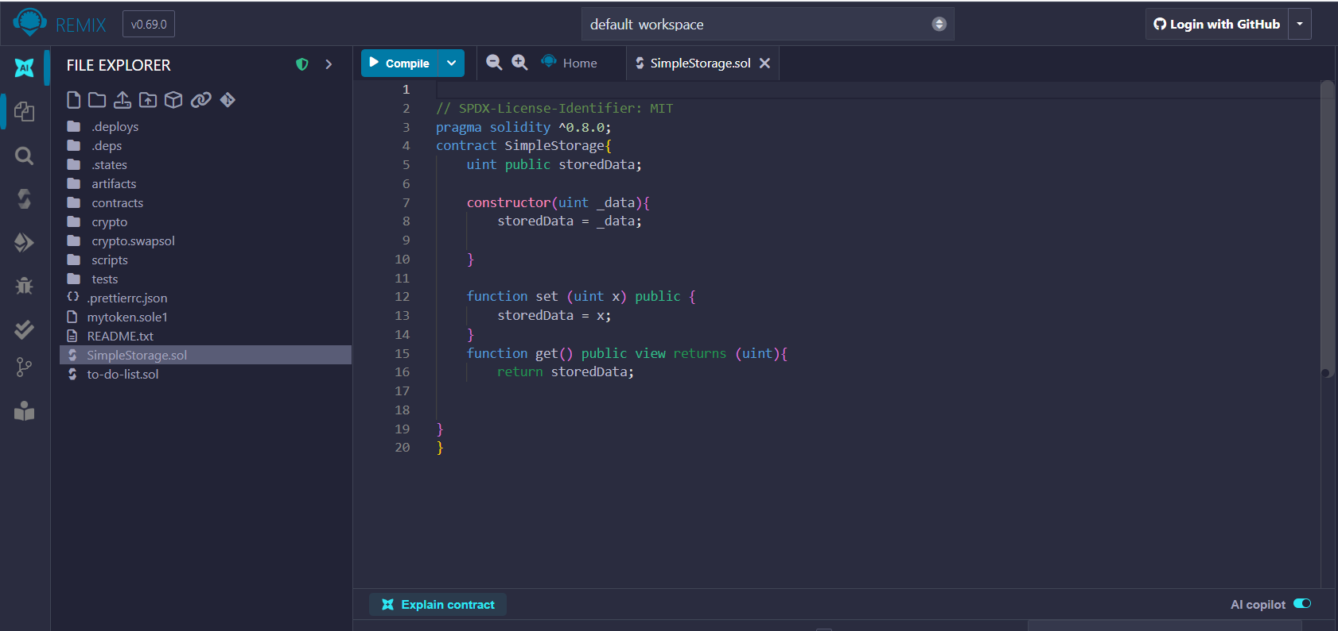

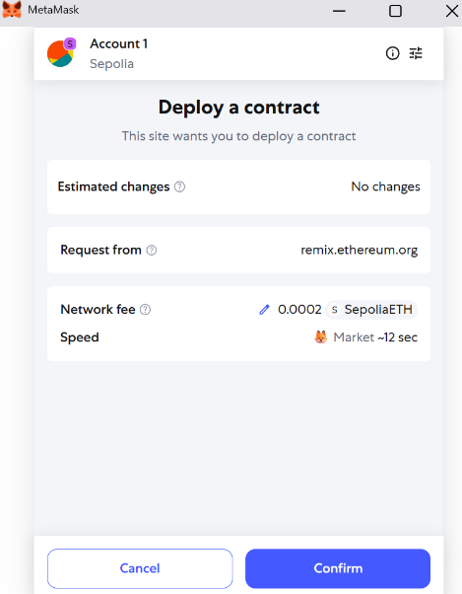

- Implementation Phase: Final Output (no error)
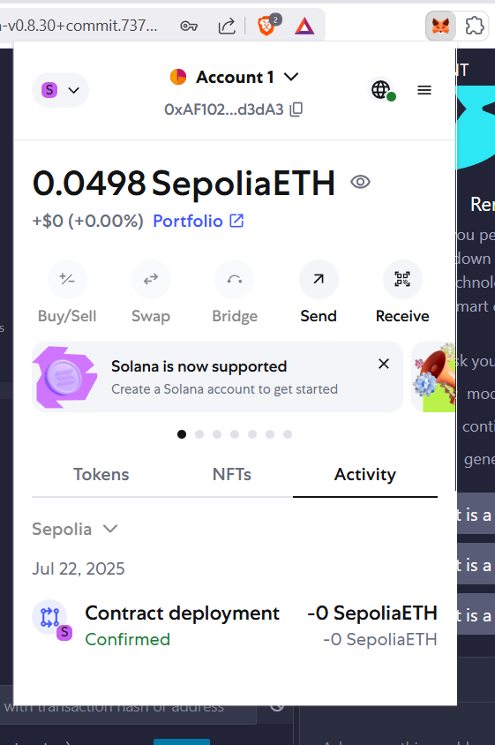

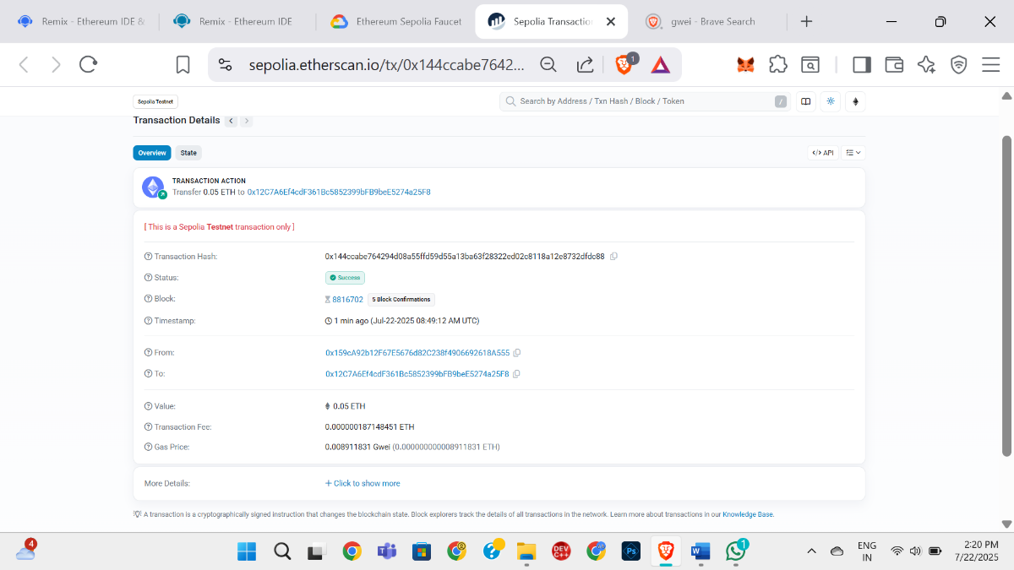

Implementation Phase: Final Output (no error)

- Implementation Phase: Final Output (no error)
Applied and Action Learning

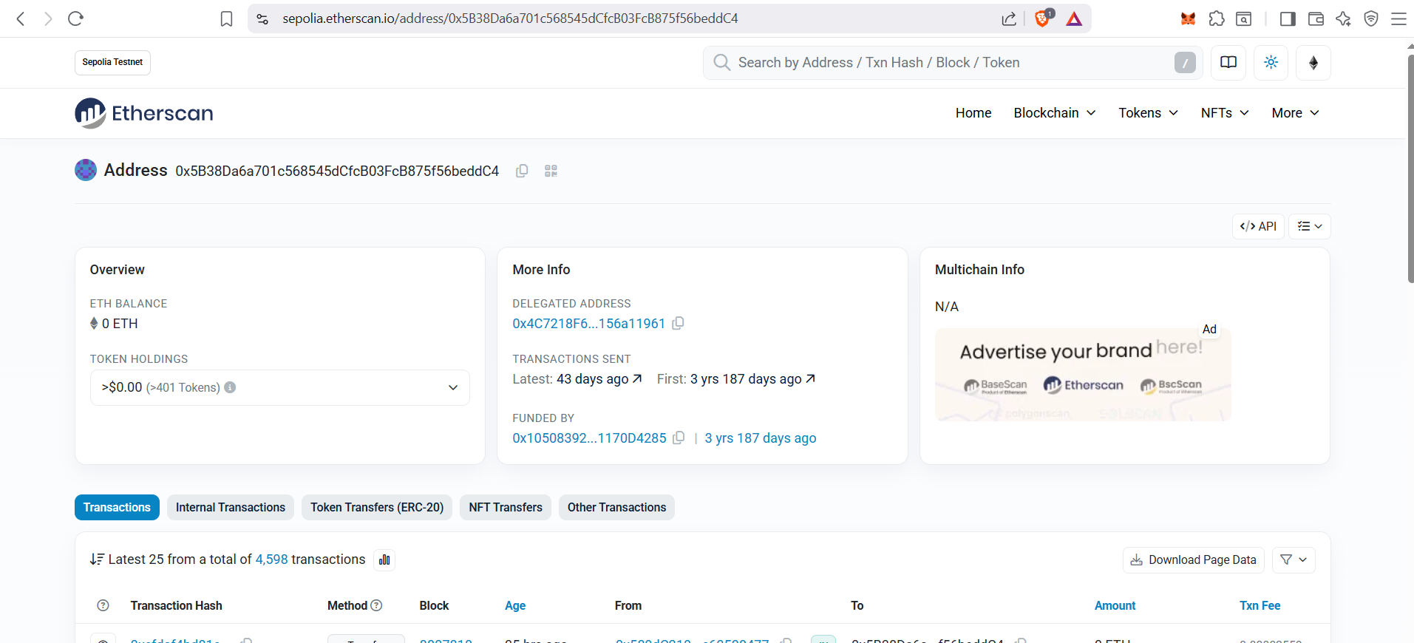

* Observations
- You can identify the exact gas usage for each executed function.
- You can verify that the call reached the right contract and ran as intended.
- You can pinpoint errors or reverts and trace the specific step that triggered them.
- You can check that all expected events were emitted with accurate data.
- You can notice excess gas usage, which helps in optimizing contract performance.
- You can confirm the sender’s identity and the exact timestamp of execution.

ASSESMENT

Rubrics
Concept | 10
Planning and Execution/  Practical Simulation/ Programming | 10
Result and Interpretation | 10
Record of Applied and Action Learning | 10
Viva | 10
Total | 50


Signature of the Student:
Signature of the Faculty:

